Customer Behaviour Analysis
Task 1

Objective
The primary objective of this project is to analyze customer shopping behavior using transactional retail data. The project aims to identify purchasing patterns, understand customer demographics, evaluate product category performance, analyze payment preferences, and segment customers based on spending behavior. Through exploratory data analysis and visualization, the project provides meaningful insights and recommendations that can help businesses enhance customer engagement, increase sales, and support strategic decision-making.

Introduction
Customer Behavior Analysis is a crucial process for understanding how customers interact with products and services. By analyzing customer demographics, purchasing patterns, payment preferences, and shopping trends, businesses can gain valuable insights that support data-driven decision-making. This project utilizes a retail shopping dataset from Kaggle to explore customer behavior through data analysis and visualization techniques. The analysis helps identify key trends, customer segments, and factors that influence purchasing decisions, enabling businesses to improve customer satisfaction and optimize marketing strategies.
Import Dataset
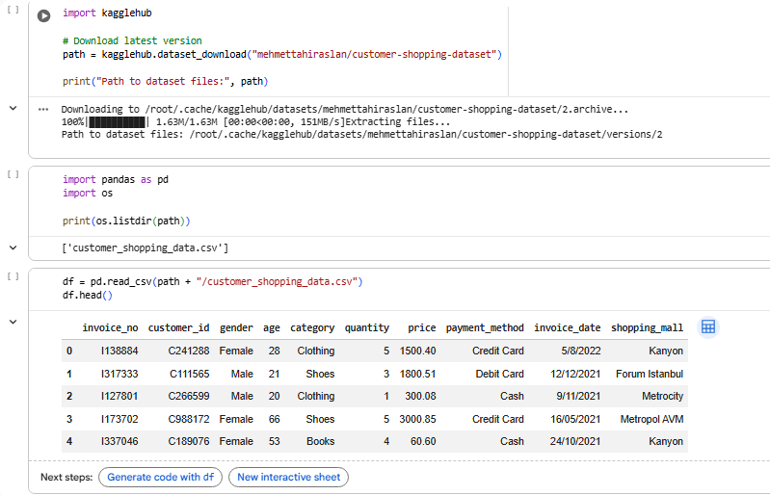
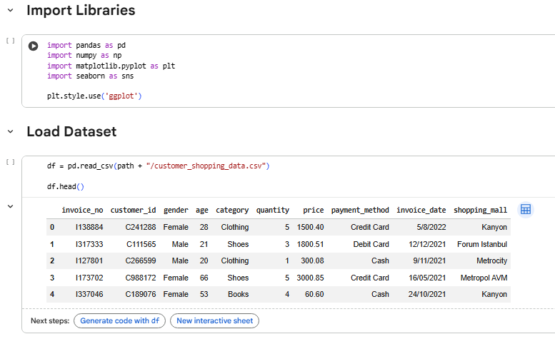
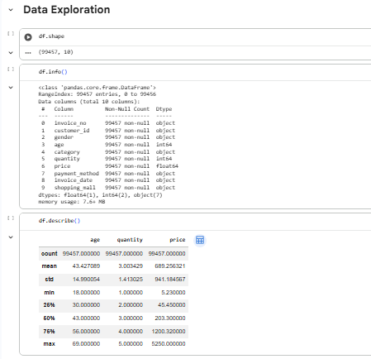
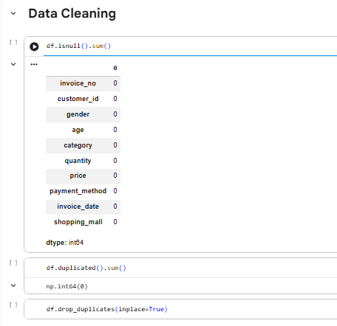
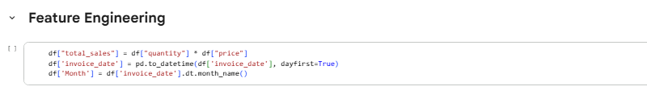

Visualizations
- Gender Distribution
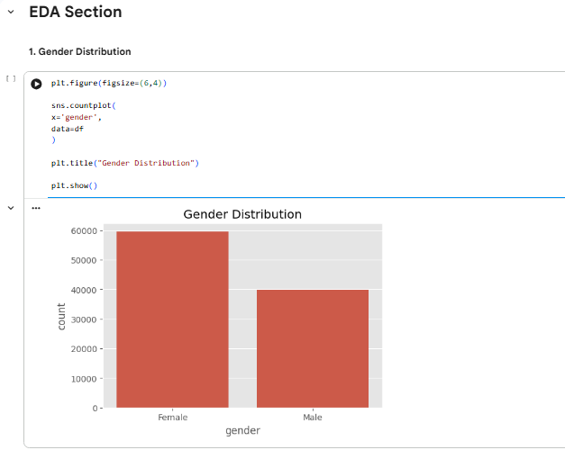
- Age Distribution
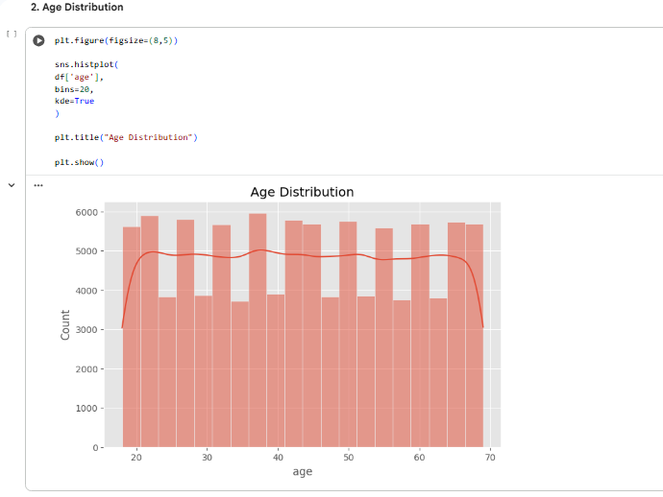
- Product Categories
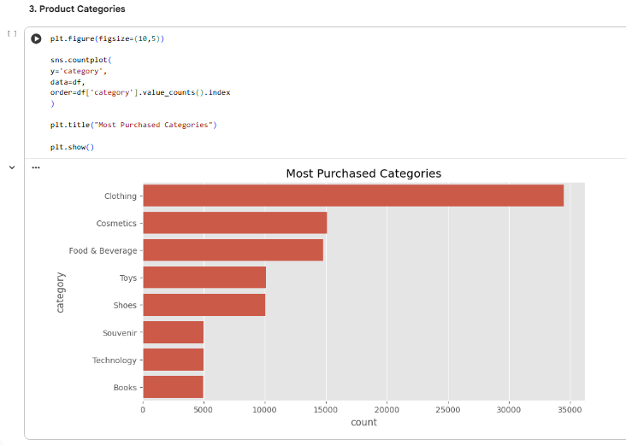
- Revenue by Category
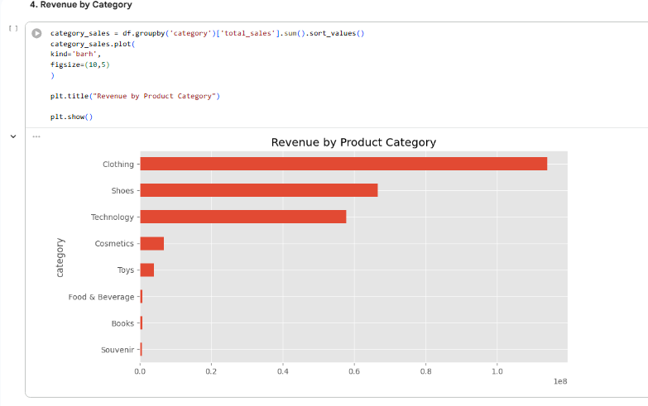
- Payment Method Preference
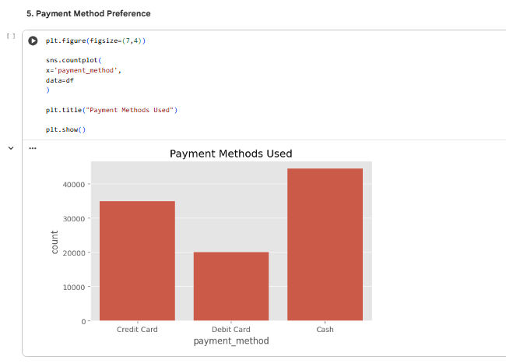
- Top Shopping Malls
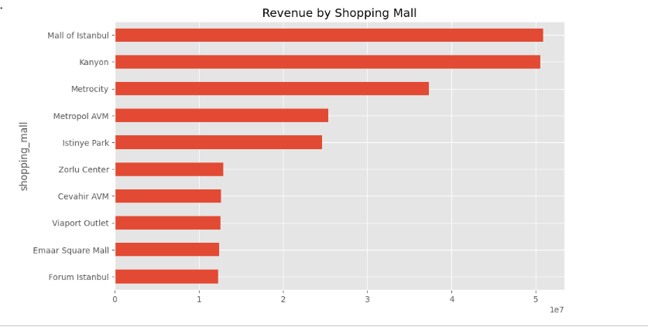
- Monthly Sales Trend
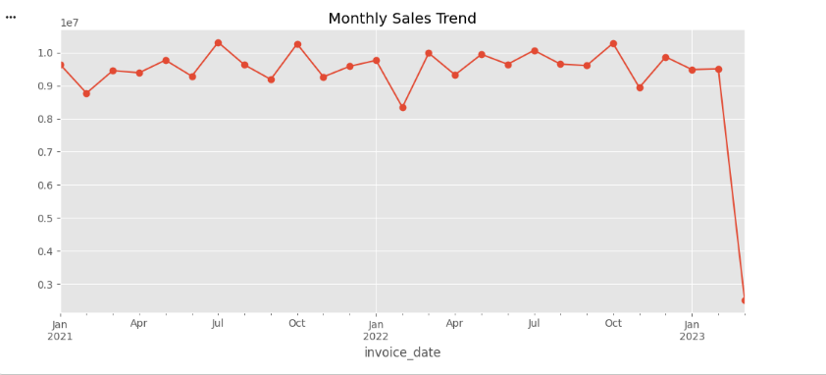

- Age vs Spending
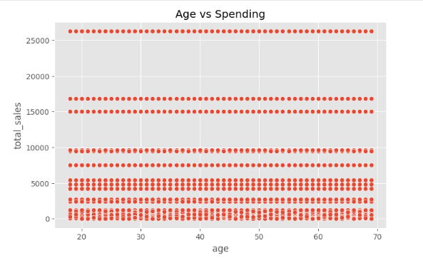
- Correlation Heatmap
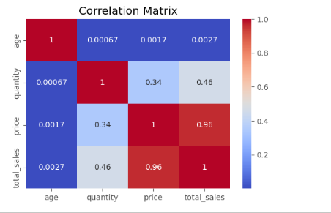
- Customer Segmentation
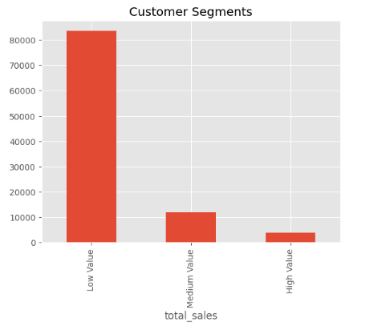
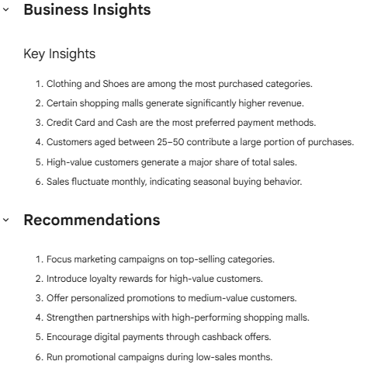
Code link :
https://colab.research.google.com/drive/14NlnK2-8VBSHvWV-I0WZLa8IqxmHzWT8
Dataset Used :
#!/bin/bash
curl -L -o ~/Downloads/customer-shopping-dataset.zip\
https://www.kaggle.com/api/v1/datasets/download/mehmettahiraslan/customer-shopping-dataset

Tools Used:
Python, Pandas, NumPy, Matplotlib, Seaborn, Google Colab, GitHub.

Executive Summary
This project focuses on analyzing customer shopping behavior using a retail transaction dataset obtained from Kaggle. The objective of the analysis was to identify purchasing patterns, understand customer demographics, evaluate category-wise sales performance, examine payment preferences, and segment customers based on their spending behavior. The analysis was performed using Python and data analytics libraries including Pandas, NumPy, Matplotlib, and Seaborn in Google Colab.
The dataset consisted of approximately 99,000 customer transaction records containing information such as customer demographics, product categories, quantities purchased, payment methods, shopping malls, and transaction dates. After performing data cleaning and preprocessing, exploratory data analysis (EDA) techniques were applied to uncover meaningful insights and trends.
The analysis revealed that customer purchasing behavior varies significantly across product categories, age groups, and shopping locations. Certain product categories generated substantially higher revenue compared to others, indicating strong customer demand and potential opportunities for targeted marketing. Payment method analysis showed a preference for digital payment options alongside traditional cash transactions. Shopping mall performance analysis highlighted variations in revenue generation across different locations, helping identify high-performing business centers.Customer segmentation based on spending patterns classified customers into low-value, medium-value, and high-value groups. The results indicated that a relatively small proportion of customers contributed a significant share of overall revenue, emphasizing the importance of customer retention and loyalty strategies. Monthly sales trend analysis also demonstrated fluctuations in purchasing activity, suggesting the influence of seasonal and promotional factors on consumer behavior.
Based on the findings, several business recommendations were proposed, including focusing marketing efforts on top-performing product categories, implementing loyalty programs for high-value customers, offering personalized promotions, encouraging digital payment adoption, and designing targeted campaigns during lower sales periods. These recommendations can help businesses improve customer engagement, increase revenue, and make more informed strategic decisions.
Overall, this project demonstrates how data analytics can transform raw transactional data into actionable business insights, enabling organizations to better understand customer behavior and enhance decision-making processes.
Conclusion
This project successfully analyzed customer shopping behavior using retail transaction data and identified key purchasing trends, customer preferences, and spending patterns. Through data cleaning, visualization, and customer segmentation, valuable business insights were generated regarding product categories, payment methods, shopping locations, and customer demographics. The findings demonstrate how data analytics can support informed decision-making, improve customer engagement, and help businesses develop effective marketing and sales strategies.

